**Interleave Controller:**

It allows us to pick and execute a single child element out of multiple child in each loop iteration. We can Add Interleave Controller using the below steps.

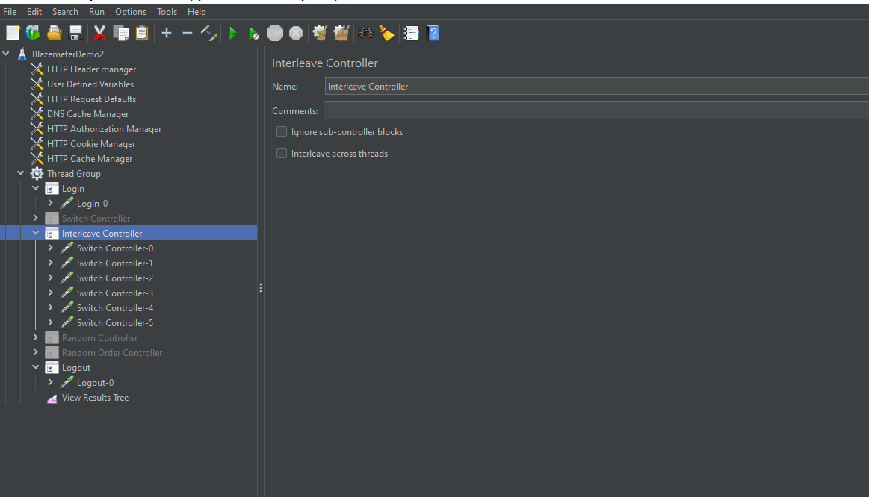

The test are executed in a way that the tests present in the interleave controller.

The test present in the interleave execute one by one after completing the each cycle .

Like First before sampler executes then the one test present in the interleave controller then next sampler result.

And this flow continues upto the executing of all the tests present in the interleave controller.

